
FACULTY OF ENGINEERING
DEGREE ENGINEERING
DEPARTMENT OF COMPUTER ENGINEERING
SOFTWARE ENGINEERING (BE103505)
Unit-6 –Software Coding & Testing

Coding Standard and Coding Guidelines

Coding Definition
Coding standards are a set of rules that programmers follow while writing code.

Purpose of Coding Standards
- Gives the same style to all programmers' code.
- Makes code easy to understand.
- Encourages good programming practices.

Code Review, Code Walk Through, Code Inspection

Code Review

Definition
Code Review is the process of checking code after compilation to find errors and improve code quality.

Purpose
- Reduces coding errors.
- Improves code quality.
- Ensures coding standards are followed.

Code Walk Through

Definition
Code Walk Through is an informal method of checking code by team members.

Process:
- Team members read and understand the code.
- They manually check the execution using test cases.
- Errors in logic and algorithms are identified.

Main Goal
- Find logical and algorithm errors.

Code Inspection

Definition
Code Inspection is a formal method of checking code to find common programming mistakes.

Features:
- Code is checked carefully for errors.
- Coding standards are verified.
- Common mistakes are identified.

Main Goal
- Find programming errors and improve code quality.

Software Documentation

Definition
Software Documentation is a collection of documents created along with software, such as user manuals, SRS documents, design documents, test documents, and installation manuals.

Importance
- Helps users understand the software.
- Helps developers maintain and modify the software.
- It is an important part of software development.

Types of Software Documentation

1. Internal Documentation
- Documentation provided inside the source code.
- Helps developers understand the code easily.

Examples:
- Module headers
- Comments
- Meaningful variable names
- Proper code indentation
- Code structure
- Constant identifiers
- User-defined data types

2. External Documentation
- Documentation provided separately from the source code.
- Helps users and developers understand the software.

Examples:
- User Manual
- SRS Document
- Design Document
- Test Document
- Installation Manual

Testing Strategies

Definition
Software Testing is the process of checking software to find errors and ensure quality.

Importance
- Ensures software works correctly.
- Checks requirements, design, and code.
- Helps improve software quality.

Testing Process
- Test engineers create test cases to find errors in software.
- Testing helps identify problems before software delivery.

Types of Testing Approach

Verification and Validation (V&V)

1. Verification
Definition:
Verification checks whether the software is developed correctly according to specifications.
Question:
"Are we building the product right?"

2. Validation
Definition:
Validation checks whether the software meets customer requirements.
Question:
"Are we building the right product?"
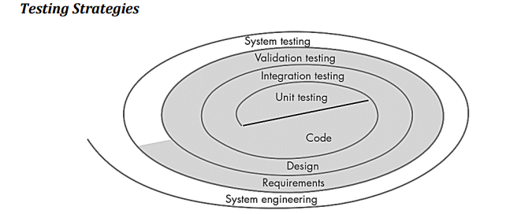

Unit Testing:

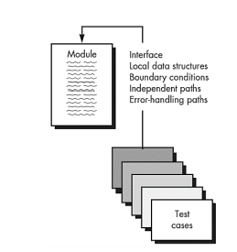

Definition
Unit Testing is the testing of the smallest part of a software system, such as a class, method, or code file.

Purpose
- Checks whether each small unit works correctly.
- Finds errors before testing the complete system.

Driver and Stub
- Driver: A small program that sends test data to the unit and displays results.
- Stub: A dummy program that replaces a module called by the unit during testing.

Integration Testing

Definition
Integration Testing checks whether different modules work correctly when combined together.

Purpose
- Tests communication between modules.
- Verifies combined functionality after integration.

Examples of Modules:
- Code modules
- Applications
- Client-server applications

Types of Integration Testing:
- Top-Down Integration – Testing starts from the top module and moves downward.
- Bottom-Up Integration – Testing starts from lower modules and moves upward.
- Regression Testing – Ensures new changes do not affect existing features.
- Smoke Testing – Checks basic functions of the software.

Validation Testing

Definition
Validation Testing checks whether the software meets customer requirements and works as expected.

Purpose
- Ensures the software satisfies user needs.
- Confirms software is ready for use.

Features:
- Checks functional and performance requirements.
- Provides final confirmation of software quality.

Alpha Testing
- Conducted at the developer's site.
- Performed by selected end users.
- Developers observe users and record errors.
- Done in a controlled environment.

White Box Testing and Black Box Testing

1. White Box Testing

Definition
White Box Testing is a testing method where the internal code and logic of the software are checked.

Features
- Tests the internal structure of the program.
- Checks code paths, loops, decisions, and data structures.
- Mainly used in Unit Testing and Integration Testing.

White Box Testing Checks:
- All paths of a program are tested.
- Logical decisions are tested (true and false conditions).
- Loops are tested properly.
- Internal data structures are checked.

Advantages:
- Testing can start early.
- Provides detailed testing of code.
- Finds logical errors easily.

Disadvantages:
- Requires skilled programmers.
- Testing can be complex.
- Difficult to maintain test cases when code changes.

2. Black Box Testing

Definition
Black Box Testing is a testing method where software functionality is tested without knowing the internal code.

Features
- Focuses on input and output of the software.
- Tests whether software meets user requirements.
- Mainly used in System Testing and Acceptance Testing.

Black Box Testing Finds:
- Missing or incorrect functions.
- Interface errors.
- Data handling errors.
- Performance errors.
- Starting and ending errors.

Advantages:
- Tests from the user's point of view.
- No programming knowledge is required.
- Can be performed by independent testers.
- Test cases can be created from requirements.

Testing Web Applications

Definition
WebApp Testing is the process of finding errors in a web application and ensuring its quality.
It checks:
- Content
- Functions
- Usability
- Navigation
- Performance
- Security

1. Content Testing
- Checks whether website content is correct and error-free.
- Finds spelling mistakes and wrong information.

2. User Interface Testing
- Checks the design and usability of the WebApp.
- Ensures users can interact easily.

3. Component-Level Testing
- Tests individual functions or parts of a WebApp.
- Finds errors in features and forms.

4. Navigation Testing
- Checks movement between pages of a WebApp.
- Tests links, buttons, search, and menus.

5. Configuration Testing
- Checks whether the WebApp works on different systems.
- Tests browsers, operating systems, and networks.

6. Security Testing
- Checks protection of data and the system.
- Finds security weaknesses.

7. Performance Testing
- Checks speed and response time of the WebApp.
- Finds performance problems.

